Git commands

Clear -clear the window

Configuration

git config –global user.name “Thomas”

git config –global user.mail “mail”

git init-new project

git clone -take already done project.

git log -show all commits

.gitignore -don’t take that folder

Git checkout -we can go to previous stage

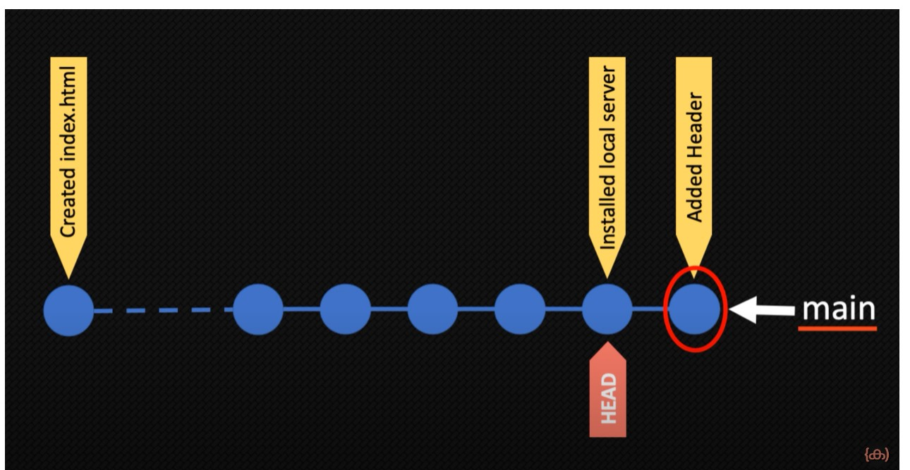

git diff

git reset - (be careful) delete the previous data

git restore